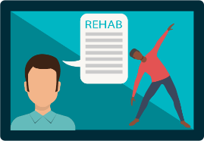
A Quick Guide for Patients on
Virtual Physiotherapy Care

What is Virtual Physiotherapy Care?

Sometimes called telehealth or telerehabilitation, a virtual visit is similar to a Facetime or Skype video call, but we use specialized software and assessment techniques to accomplish physiotherapy goals.
We can measure your movement online, stream exercises and instruct you to understand how much, how often, and how hard you should do that exercise, educate you on your injury, use specialized digital tools for tracking your progress, and more. You might be surprised by working together just how much we can do!
How will I connect to the call?
We use [enter name of software solution] for our virtual physiotherapy visits. We will send you an email that has the key details for the visit including an appointment time and a special “link” that you click to enter the visit.
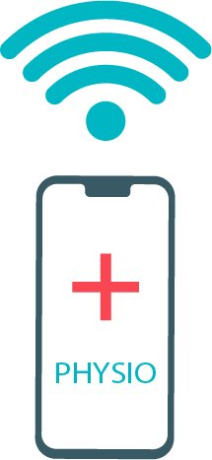
What device should I use?
Ideally, if you have a laptop/desktop with a webcam and microphone that you know how to work, that gives you the best view of the exercises and other content we use. However, a tablet or phone will work for your first connection as well. Use what you are most comfortable with and we can discuss any needed changes in your first visit.

Who can I call if I have difficulties with the connection?
We all know online video sessions are not without their problems! There are many different variables that can sabotage even the most well-planned call! If you are having difficulty, call our office at [contact number] – our staff are trained in helping you connect.
Are there any other tips for me?
Yes, here are a few:
- Use a pair of headphones to begin the session or have them close by. These will solve a lot of audio issues.
- Give yourself lots of space! This is physiotherapy after all, and it is likely we will have you move.
- Don’t feel bad if things go wrong. This is new service for all of us in Canada and we are working out how it works best. You will not be charged if something stops you from having a quality visit.

